**European Pattern Recognition - Renewable Energy Impact**

**Work Package 7: Inertia Support**

LITERATURE REVIEW

**Contents**

1 Introduction 3

2 Current Studıes 4

3 GRID CODES 5

4 Current PMSG Wınd turbınes 6

4.1 modellıng 6

5 INERTIAL SUPPORT 8

5.1 Synthetıc ınertıa Theory 8

5.2 Inertıal Support Methods 8

5.2.1 Torque limit based inertia support 9

5.2.2 Frequency based inertial control 9

5.3 ACTIVATION SCHEMES 10

5.3.1 Continuously Operating Triggering 10

5.3.2 Under Frequency Trigger 10

5.3.3 Maximum Frequency Gradient Trigger 10

5.4 grıd ınertıa estımatıon 10

6 conclusıon 12

7 References 13

# Introduction

The share of renewable energy in the installed capacity is increasing day by day. The installed wind power capacity has reached 159.5 GW in the Europe at the end of July 2017 [1]. According to the low and high scenarios, additional 42 GW and 65 GW will be constructed until 2020 [1]. These additional wind turbines and photovoltaic systems will constitute a significant share of the installed capacity. Hence, the electric grid was subjected to change and it will be subjected more in the upcoming feature. All these numbers mean environmentally friendly feature however; it should be noted that this increasing renewable penetration makes the system operation harder and brings challenges with it.

The voltage regulation is one of these challenges coming with renewable sources. Since the power generation depends on the renewable source type, the power cannot be delivered with the commanded values. Therefore, renewable sources in the medium voltages causes the bi-directional power flows that results in voltage variations in the grid. Situation gets worse in the low voltage system since it is based on the radial design. In other words, low voltage system is designed on the assumption that the power flows from the generating facilities to the customer. Nonetheless, the customer is also starting power generation time to time and causes voltage regulation problems.

Another and maybe the most important problem coming with increasing renewable penetration is the frequency stability problem. The grid frequency depends on the balance between generation and the consumption. However, the uncertainty in the renewable power generation makes the frequency regulation harder. The system operator activates and deactivates the generators continuously and this operation is getting harder with high renewable penetration. Aside from that, the grid equivalent inertia is decreasing. For instance, the power electronics existing in the wind turbines decouples the grid frequency from the wind turbine speed. In this way, turbine can be operated in a point which gives best aerodynamics efficiency. However, the decoupled turbine speed would make the operation much different than the synchronous machine concept. The synchronous generators are key elements in the grid for frequency deviations and grid frequency falls are arrested with the help of the synchronous generators inertia. However, grid inertia decreases with the increasing penetration of the renewable sources. Therefore, the electric grid will face the problem of frequency stability without any modification to the existing system structures.

In order to solve this problem, wind turbine inertia should be reflected to the grid frequency. By changing the turbine speed based on the grid frequency, turbine inertia is made visible to the grid side. ‘Synthetic Inertia’ is the method of achieving this grid frequency coupling in the renewable sources. By using this method, renewable energy sources can imitate the synchronous generator behaviours to grid frequency deviation. It can also be noted that, by making use of power electronics, wind turbines can act same as synchronous generators or even better inertial response can be delivered to grid.

In this report, the literature review for the WP 7 has been reported. By making use of this report, the EnerjiSA wind farm located in Balıkesir can be modelled in simulation environment, the synthetic inertia modification can be achieved and capacity of the wind farm can be revealed. At the end of this study, potential of the BARES wind farm for inertial support will be found. This support can also be tested for frequency disturbance events created on the simulation environment. Finally, the efficiency of such modification will be found and it might give some advices to the system operator, TEİAŞ in Turkey.

# Current Studıes

Buraya frekansı koy ya

# GRID CODES

With the high amount of renewable penetration, grid codes are also subject to change. The needs of the system operators differ with the amount of renewable source installed in the grid. In the early days of renewable sources, main desire was obtaining as much power from the renewable source instead of using conventional sources. The renewable sources are supported by incentives, subsidies and no additional expectation from renewables. However, increasing amount of renewable starts creating problems in the system operation. For instance, renewable sources disconnect themselves when a disturbance occurs in the system. This made the system even worse with disconnections of renewables. Thereafter, the grid codes start covering under voltage cases and disconnect conditions. Low Voltage Ride Through (LVRT) is defined in the grid codes

# Current PMSG Wınd turbınes

## modellıng

The main control diagram of the PMSG wind turbine is given below. In the figure, the aerodynamic model represents the wind turbine structure which captures power from the air. The mechanical model represents the generator and wind turbine connection via gearbox.

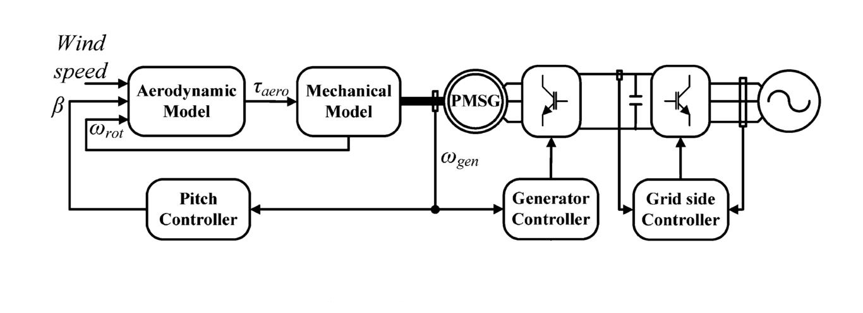

Figure 1: Main Control Diagram of the PMSG Wind Turbine [2]

The aerodynamic power captured from wind depends on the wind speed, pitch angle and the rotational speed. The term power coefficient, Cp is the aerodynamic efficiency of the operating point of the wind turbine. Therefore, the responsibility of pitch controller and generator side controller is to maintain the maximum efficiency.

|  |  |
| --- | --- |
| Pt = 0.5 Cp(λ,β)Aρυ3 | (4) |

Permanent magnet coupled to wind turbine shaft is connected to grid with the Back-to-Back(BTB) Converter structure. This structure gives operator freedom of control. Therefore, by making use of BTB converter, the operator can define active and reactive power set points independently. BTB converter is composed of two different structure. The first one is the generator or machine side controller (MSC) which is connected to machine side. The other one is connected to grid side and hence it is called grid side converter (GSC).

The responsibilities are shared between these converters. MSC is responsible for speed reference and the active power reference meanwhile the GSC is responsible for the reactive power reference (also the power factor) and the DC voltage reference. As seen the figure below, the generator speed is dictated by controlling the q-axis current. This generator speed should be the maximum power point which is generally taken from look up table.



Figure 2: Machine Side Controller

Grid Side Controller is responsible for maintaining constant DC voltage and the reactive power amount. Reactive power amount can be set by controlling the q-axis current. For normal operation, wind turbines and also other renewable sources are desired to operate at unity power factor. This is achieved by setting zero for the q-axis current. Note that for the LVRT capabilities, this set point would change time to time. GSC is also responsible for maintaining the constant voltage in the DC link.



Figure 3: Grid Side Controller Diagram

# INERTIAL SUPPORT

## Synthetıc ınertıa Theory

Conventional synchronous generators are strictly coupled to grid frequency which determines the synchronous speed of the generator. Therefore, any deviation of the frequency creates a deviation in the synchronous speed and hence generator speed inherently. The change in the generator speed extracts or stores kinetic energy in the generator inertia depending on the frequency deviation direction. This extracted kinetic energy is pushed or absorbed from grid in the form of active power and defined as inertial support. Hence, synchronous generators assist to stability of the grid frequency until frequency control actions.

Nonetheless, renewable sources, especially the ones coupled to grid with PE, have no contributions to grid frequency. The change in grid frequency does not affect the active power pushed to grid. Synthetic inertia is the method that relates the grid frequency and active power of the renewable sources. However, the active power captured from the renewable source (solar radiation, wind etc.) is said to be constant for an instant. Hence, in order to increase the active power for the critical moments, the only possibilities are either spare energy source or stored energy. In WTs, there is high amount of stored energy in the blades and generator inertia in the form of kinetic energy according to Equation (1).

|  |  |
| --- | --- |
| Estored = Jtotal | (1) |
| Tt-Tg = Jtotal | (2) |

In WTs, active power can be increased by utilizing stored energy for short periods. In order to extract this energy, turbine speed should be decreased by adjusting speed reference of the Machine Side Controller (MSC). In the normal operation, shaft speed is constant since the turbine torque is equal to the generator torque in the Equation (2). In order to decrease the turbine speed, generator torque should be increased. This is achieved by adjusting the speed reference of the MSC. When the speed reference is decreased from the Maximum Power Point (MPP), MSC increase the generator torque in order to slow down.

|  |  |
| --- | --- |
| P= Tg ωg | (3) |

Power injected from the WTs is the multiplication of generator torque and the speed of the generator as shown in Equation 3. The commanded speed reference will increase the torque to higher value in order to decrease the speed. However, due to the inertia of the WT, the speed of the turbine will not change immediately. Therefore, as the torque value is increased, the power injected from the turbine will increase since the speed of the turbine is momentarily constant. Notice that these additional active power is extracted from the kinetic energy stored in the turbine, hence the generator speed will decrease. The active power will also decrease firstly to the starting point, then a lower value in order to recover the speed of the turbine to the MPP speed reference. In this way, the active power can be increased in the frequency deviation instant. Note that the method is explained for frequency decrease case which is the main problem of the grid due to the fact that generator outage and load connection occurs

## Inertıal Support Methods

The inertia support from a wind turbine should be supplied from some energy stored in the wind turbine due to the fact that the amount of energy captured from the wind is constant for momentarily. Therefore, the WT should make use of either the stored kinetic energy in the turbine inertia (blades, gearbox and generator inertia) or the stored electrostatic energy in the DC link capacitor.

There are two main methods in the literature. Both method modifies the torque set point of the generator so that the whole system slows down and extracts the kinetic energy stored in the total inertia of the wind turbine.

### Torque limit based inertia support

In this type of inertial control, the system slows down with the limit torque. The limit torque is carefully selected for the secure operation. Torque limit is generally selected as 1.2 pu. The slow down operation is maintained until the pre-defined minimum speed. Inertial support is activated when the frequency excursion exceeds the dead-band.

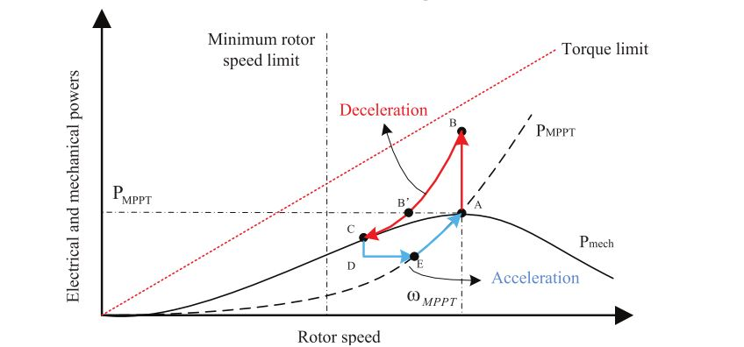

Figure 4: Torque limit based inertial support power-speed graph [3]

### Frequency based inertial control

In this type of control, the torque set point of the turbine is adjusted based on the rate of change of the frequency. Aside from the torque limit based control, torque set point is adjusted according to the deviation in the frequency. Note that grid frequency has continuous ripples. Therefore, before the derivative operation, the frequency should be filtered. Hence, the steepest decline in the frequency will result in higher torque and higher active power.

Additional power can also be extracted from the DC link capacitor if the voltage set point of the DC link is also adjusted depending on the frequency deviation. However, it should be noted that the stored electrostatic energy is much lower than the kinetic energy stored in the turbine inertia.

Furthermore, in the studies [4],[5],[6], the inertia support is achieved by the Phase-Locked Loop optimization. The proposed method puts a delay on the PLL compensator and it results in higher phase angle and hence, higher active power. Nevertheless, all methods results in higher active power and this power is taken from the turbine kinetic energy.

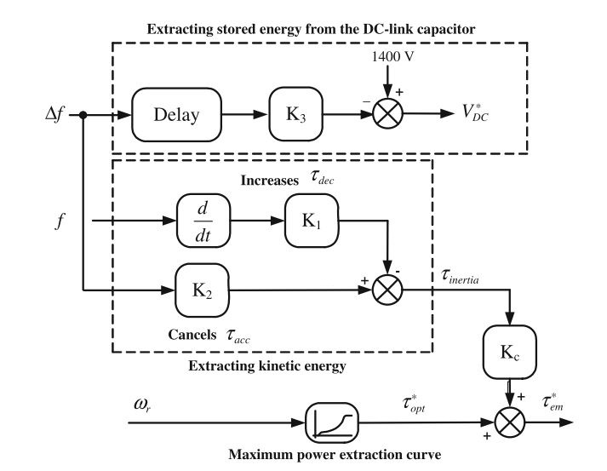

Figure 5: Frequency based inertial support control diagram[2]

## ACTIVATION SCHEMES

Another important issue about the inertial support is the activation scheme. There are three main activation schemes listed in the study [7].

### Continuously Operating Triggering

It is possible to trigger the support continuously. However, this is an unrealistic and ineffective way to trigger. By triggering continuously, wind turbine would be operating away from the maximum power point. Moreover, by considering the continuous deviation in the grid frequency, this operation might be quite chaotic. Therefore, this scheme should be avoided.

### Under Frequency Trigger

In this activation scheme, the inertial support mechanism is activated by considering an under frequency threshold. As soon as the frequency falls below the threshold, inertia support is activated. In this triggering criteria, threshold selection is quite important.

### Maximum Frequency Gradient Trigger

This scheme is similar to the under frequency trigger. However, the support is activated by rate of change of frequency threshold rather than minimum frequency threshold. By comparing the rate of change of frequency, the significance of the disturbance can be measured and the decide can be made on whether to support or not support the frequency.

## grıd ınertıa estımatıon

Inertia of the electricity grid is quite important in terms of frequency stability. The higher amount of inertia results in higher amount of kinetic energy stored in inertia of the generators. The frequency of the grid changes according to the swing equation which is given Equation ().

$$\frac{2H}{f_{0}}\frac{df}{dt}=P_{m}-P_{e}$$

Grid frequency remains the same if the grid generated power is equal to the consumed power. If not, grid frequency starts to deviate from nominal value. Therefore, for the system operators, the knowledge of the grid inertia gives an opinion about possible frequency deviation for the disturbances in the grid. Therefore, estimating the present inertia of the grid is the desire of the system operator for the security reasons.

By investigating the power and frequency measurements, one can estimate the inertia of the generators by using the swing equation. It is possible to sum up all the generator inertia constants in theory. However, it is not possible to reach these measurements at each generator bus. Therefore, the general practice is gathering as much measurements as possible to estimate the aggravated inertia of the grid with high accuracy.

One of the important point related to inertia estimation is the measurement and disturbance points. If the measurements are taken from far away point from the disturbance point, then the estimated result will be erroneous. Therefore, collecting as much measurements as possible and the spreading these measurements to grid operators’ responsible area will decrease the error in the estimation.

In study [8], aggravated inertia of the Great Britain is estimated by using synchrophasor measurements. This study states that the location of the disturbance and the measurement has huge importance on the accuracy of the estimation. Moreover, as the PMUs are involved in the measurements, the accuracy increases significantly. In the study [9], generator inertia is estimated by using the rate of change of frequency and the active power of the generator. One of the challenges with inertia estimation is the dependence of the power on the frequency. Even though the disturbance is known in the system, the active power difference would be different than the disturbance value. Study [10] discusses the load power on the frequency dependence.

# conclusıon

# References